Researchers develop molecule that boosts cord blood stem cells
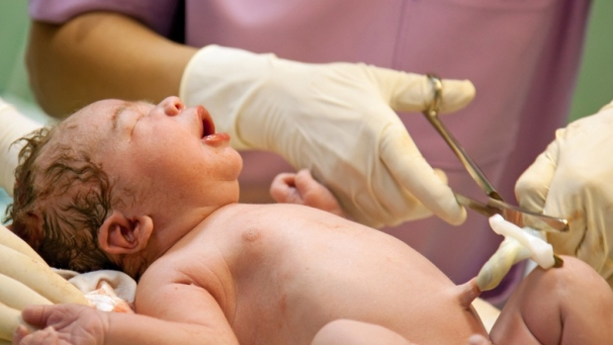

TORONTO -- Canadian researchers have found a way to boost the number of stem cells in umbilical cord blood so more patients with leukemia and other blood-related cancers could receive potentially life-saving transplants.
The key to the breakthrough technique is a molecule developed at the Universite de Montreal, coupled with a bioreactor designed at the University of Toronto, which allows scientists to significantly expand the number of stem cells from a single unit of cord blood.
"Basically it's going to give access to about 10 times as many cords in (cord blood) banks," said Dr. Guy Sauvageau, principal investigator of stem cell genetics at the Institute for Research in Immunology and Cancer at the Montreal university. "It's as if you were to multiply by 10 today the number of cord blood units in the world."

The molecule, called UM171, was discovered serendipitously. It had been created by a chemist at the institute working on another program but didn't work for its intended purpose, "so they just threw it in what we call a library of compounds," Sauvageau said Thursday from Montreal.
When his research team began testing compounds from among thousands in the library, UM171 "was the only one that really worked."
Stem cells from donated umbilical cord blood are able to give rise to all the types of cells that make up blood, including the immune cells that protect the body and fight infection. The same is true of bone marrow, but finding a suitable donor is more difficult.
For some people with blood-related cancers like leukemia, myeloma and lymphoma, getting a stem cell transplant to replace their own blood system is often the treatment of last resort.
But the biggest hurdle for doctors is finding enough cord blood stem cells that are a compatible match and won't cause severe rejection symptoms in recipients, he said. Typically, there are not enough stem cells in a single cord blood unit to regenerate an adult's blood system; only five per cent of cord blood bank units can be used for large adults.
"And there's another reason why this is becoming more of a problem, because we have more and more ethnic groups in our society and these people's access to a matched unrelated donor is more limited than for most Caucasians."
That was the case for Mai Duong of Montreal, who is fighting her second bout of leukemia. The 34-year-old mother had made a desperate online plea and a global search for a donor of either bone marrow or cord blood stem cells for a transplant. On Tuesday, doctors announced an unidentified woman had donated her infant's umbilical cord to the Vietnamese-Canadian to help save her life.
Ironically, Duong is being treated at Maisonneuve-Rosemont Hospital, where the bioreactor created by Peter Zandstra in Toronto will be housed to generate stem cells for a clinical trial set to start in December to assess their safety. Three centres -- in Montreal, Quebec City and Vancouver -- will be involved in the transplant study.
"She would have been very eligible (for the study) because her chance of getting a better match would increase and her chance of getting a faster recovery of her blood count would be multiplied significantly," Sauvageau said of Duong.
The ability to magnify the yield of stem cells from cord blood would increase a patient's likelihood of finding a suitably tissue-matched donor, say researchers, whose report on UM171 was published Thursday in the journal Science. And having a greater pool of donor stem cells to transplant in a patient would mean fewer complications and faster recovery.
"Simply, the more stem cells you give, the faster the recovery after transplant. So instead of taking 25 days, they can probably do it in 10 days," predicted Sauvageau, whose lab has spent 19 years searching for the means to amplify stem cell numbers. "And this is a very precious time because that's the time when people are extremely sensitive to infection."
Achieving as close a match as possible between donor and recipient is critical to prevent chronic rejection problems, which can result in devastating illness and months in hospital. It is also fatal in 10 to 40 per cent of cases.
"So that's very important," he said. "And having this molecule will allow us to perfectly match a significant proportion of adults now."
Sauvageau, paying tribute to his team of collaborators from across Canada, believes UM171 could be a game-changer in the stem-cell transplant field.
"This new molecule, combined with the new bioreactor technology, will allow thousands of patients around the world access to a safer stem cell transplant. Considering that many patients currently cannot benefit from a stem cell transplant for lack of matching donors, this discovery looks to be highly promising for the treatment of various types of cancer."
Mick Bhatia, director of the Stem Cell and Cancer Research Institute at McMaster University, agreed UM171 looks promising because it appears to overcome the challenge of getting cord blood stem cells to regenerate and renew themselves outside the body, in a lab dish.
"That's been very tricky," said Bhatia, a blood stem cell scientist who was not involved in the research.
"So this drug, this molecule, that they've got seems to provide some magic potion to put into the culture dish and increase the number of blood stem cells they started with," he said from Hamilton.
Bone-marrow transplants are known to work well as a treatment, but finding a compatible donor can be a formidable undertaking, he said. Cord blood is a more readily available source of stem cells but is limited because it "comes in a small package."
"So what they've really done is they've taken a molecule, taken a small package, and made it into a big package. And now it's more useful.
"So it's fantastic. It's quite a breakthrough, I think."

